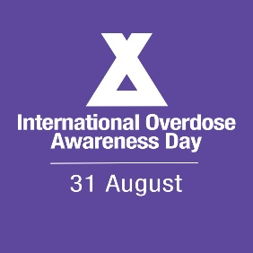
[Address of recipient – only put something here if it is a letter]

Subject: International Overdose Awareness Day 2021
Dear [Name of Recipient],
On August 31st, people in [your state or country] will observe the 21st International Overdose Awareness Day.
International Overdose Awareness Day (IOAD) is about remembering the loved ones we have lost and acknowledging the grief of family and friends left behind.
It also about taking real action to save lives.
This year, the cause is more important than ever.
Because the evidence is clear: COVID-19 is leading to increased drug-related harms in [your state or country].
It is also clear that COVID-19 is creating enormous challenges for your government and our health system.
But we simply cannot ignore the other health crisis staring us in the face.
Can we count on your support this International Overdose Awareness Day?
There are many ways your government can participate. Here are just some ideas:
- You can issue a proclamation recognising August 31st as International Overdose Awareness Day in [your city or state].
- You can fly flags at half-mast over government buildings.
- You can make it easier for people to access lifesaving Narcan (naloxone) or opioid substitution therapies that help them stay safe.
- Invite the community to light candles in their homes to remember people who have passed away because of overdose.
- Host a webinar to raise awareness of overdose as a community issue.
These are just some of the many types of ways you can support this movement and show your support for the many families in [your city or state] affected by overdose.
The International Overdose Awareness Day website has many helpful resources to help your planning, including an Ideas Bank and a Digital Event Guide should you decide to participate online.
Together, we can make a difference this International Overdose Awareness Day.

Sincerely,
[Your name]

