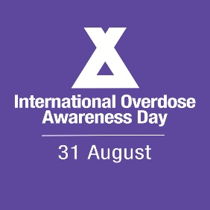
[Address of recipient – only put something here if it is a letter]

Subject: International Overdose Awareness Day 2021
Dear [Name of Recipient],
On August 31st, people in [your state or country] will observe the 21st International Overdose Awareness Day.
International Overdose Awareness Day (IOAD) is about remembering the loved ones we have lost and acknowledging the grief of family and friends left behind.
It also about taking real action to save lives.
This year, the cause is more important than ever. Because COVID-19 is leading to increased drug-related harms around the world.
Despite the challenges posed by COVID-19, we simply cannot ignore the other health crisis staring us in the face.
Can we count on your support this International Overdose Awareness Day?
One of the most spectacular ways the campaign recognises those no longer with us is by illuminating local buildings purple.
Last year, many landmarks around the world were lit purple – and this year promises to see even more.
It would be fantastic if [name of township, city or state] could honour the people who have passed away from overdose by organising to have [name of local building] lit purple.
It would send a powerful message of support for the families in [name of township, city or state] affected by overdose.

Sincerely,
[Your name]

