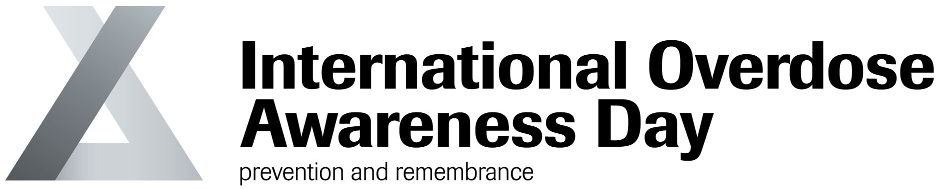

Dear [Name],

As you may be aware, International Overdose Awareness Day activities are held in communities around the world every year on August 31st. This year we invite you to support our event in [insert details of event].

The number of registered activities world-wide has grown from 75 in 2013 to nearly 500 in 2017 and 2018 promises to be even bigger.

International Overdose Awareness Day aims to raise awareness of overdose, reduce the stigma of drug-related deaths and remember those who have died or suffered permanent injury due to drug overdose. It is also an opportunity to stimulate discussion about evidence-based overdose prevention and drug policy.

International Overdose Awareness Day offers all who have been affected by overdose a chance to publicly mourn and help the community learn about drug overdose.

The day also serves as a warning that not only illicit drugs are dangerous and no-one is immune to overdose. More details about International Overdose Awareness Day are available here: https://www.overdoseday.com/.

We are hoping we can count on your support in promoting this year’s event on August 31st. You can help us by attending our event at [insert event details] or donating some money to help our event reach as many people as possible.

If you can’t make our event this year but would still like to be involved there are plenty of other ways to support International Overdose Awareness Day. We encourage you to:
- Wear the badge and wristband, which can be ordered online at https://www.overdoseday.com/shop/;
- Raise awareness through social media using this year’s hashtags #OverdoseAware and #EndOverdose; and
- Spread the word through your networks to other organisations and individuals who may be interested in our event.

Best wishes for International Overdose Awareness Day 2018.

Yours sincerely,

[Your name]

International Overdose Awareness Day is organised by Melbourne-based organisation Penington Institute (www.penington.org.au) - email: info@overdoseday.com.au

